How to create Maven Project in Eclipse ?

* Click on File 🡪 New 🡪 Project

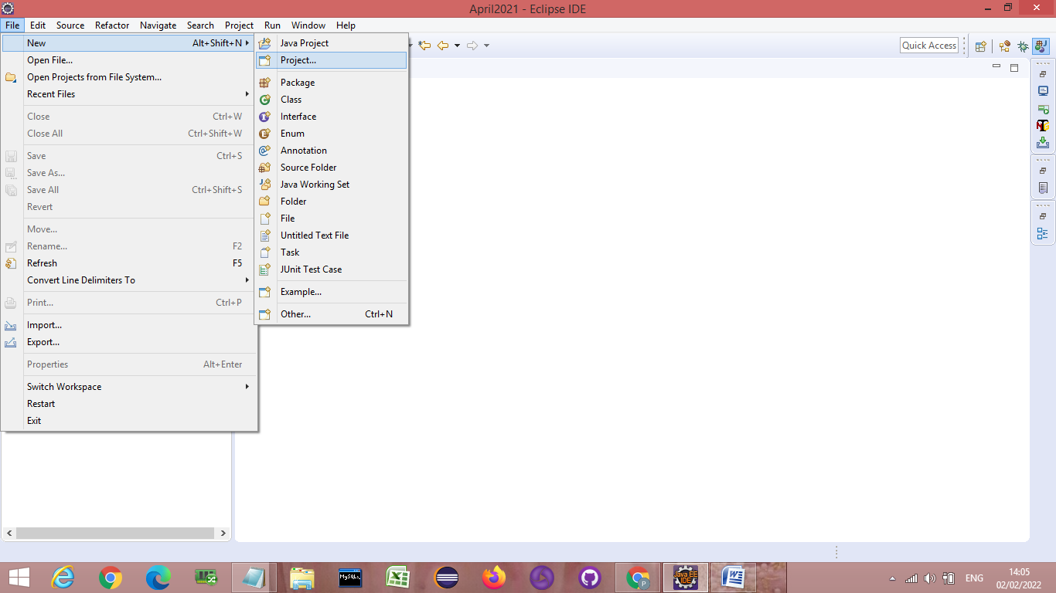

* Click on Maven Folder 🡪 Maven Project 🡪 Click Next
* 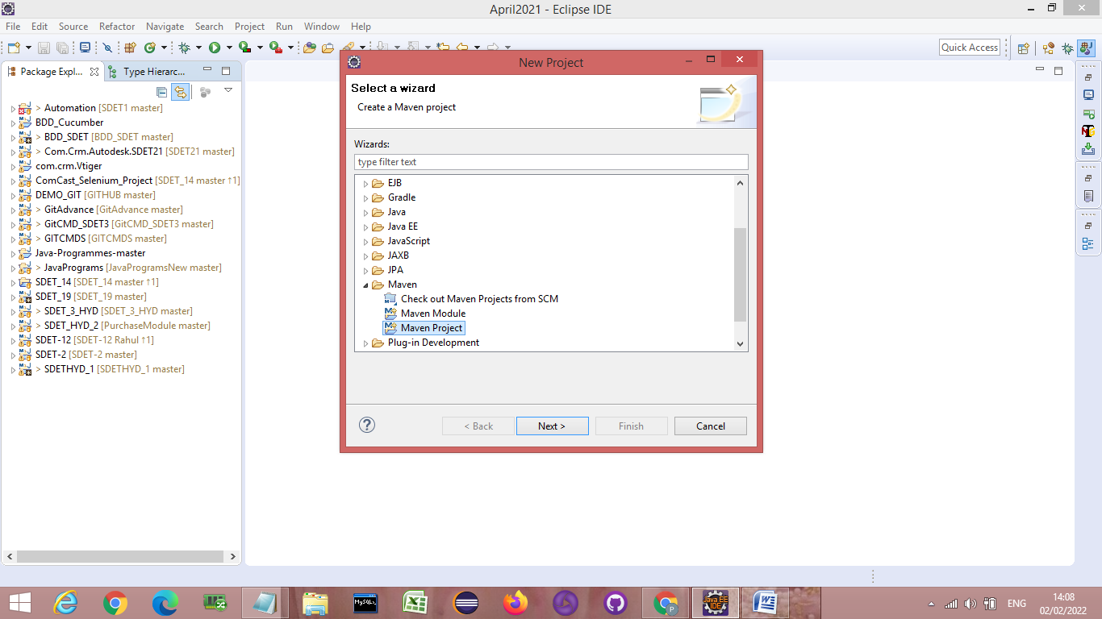

🡪 Select the Workspace 🡪 Don’t click on the first checkbox 🡪 Click on Next

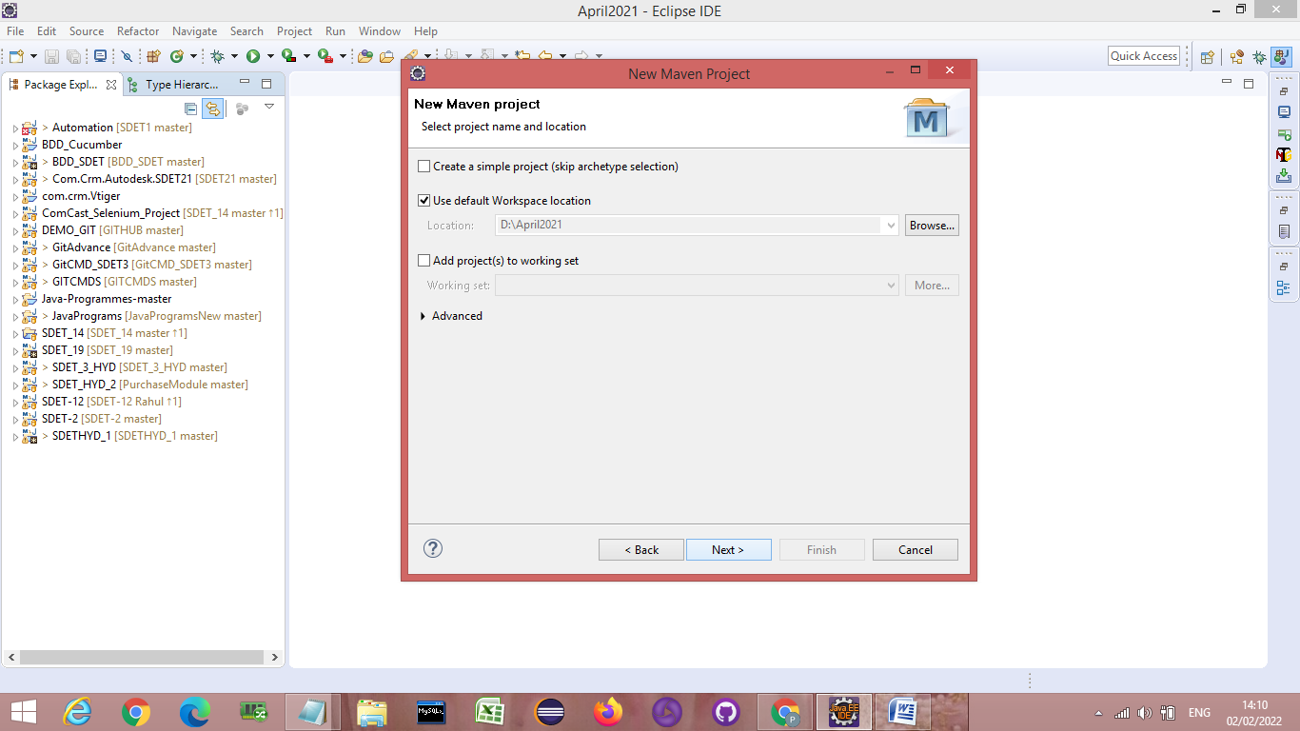

🡪Click on Configure 🡪

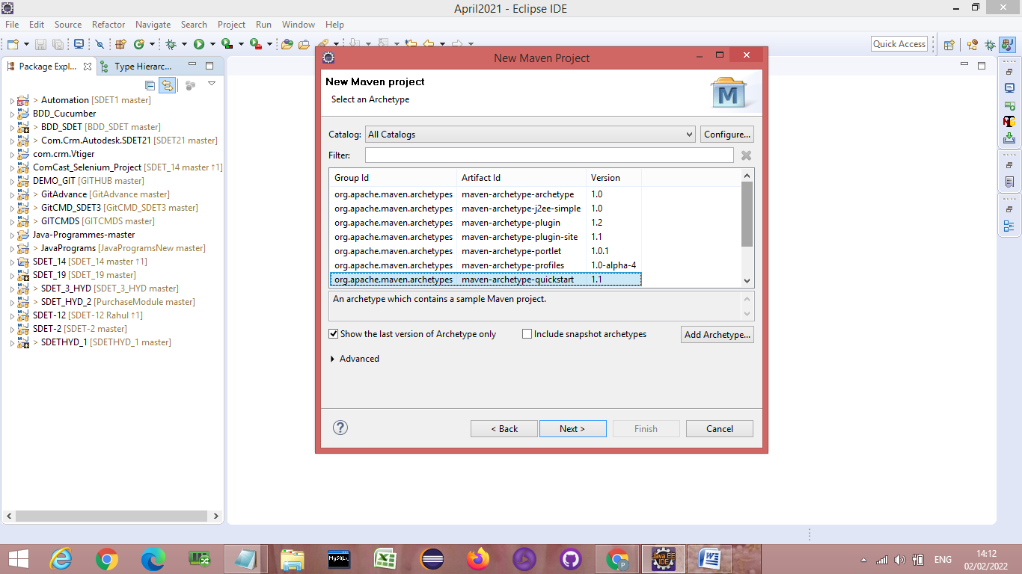

🡪 Click on Add remote catalog

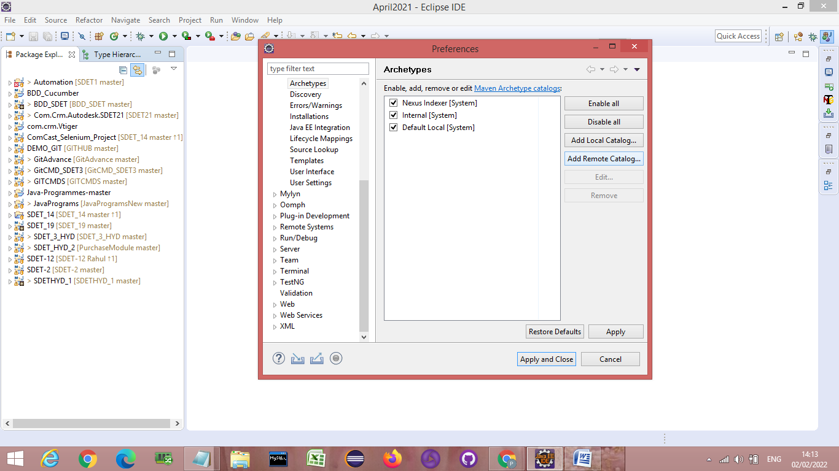

🡪Add the below link in catalog file textbox 🡪 then Click on OK

[**https://repo.maven.apache.org/maven2/archetype-catalog.xml**](https://repo.maven.apache.org/maven2/archetype-catalog.xml)

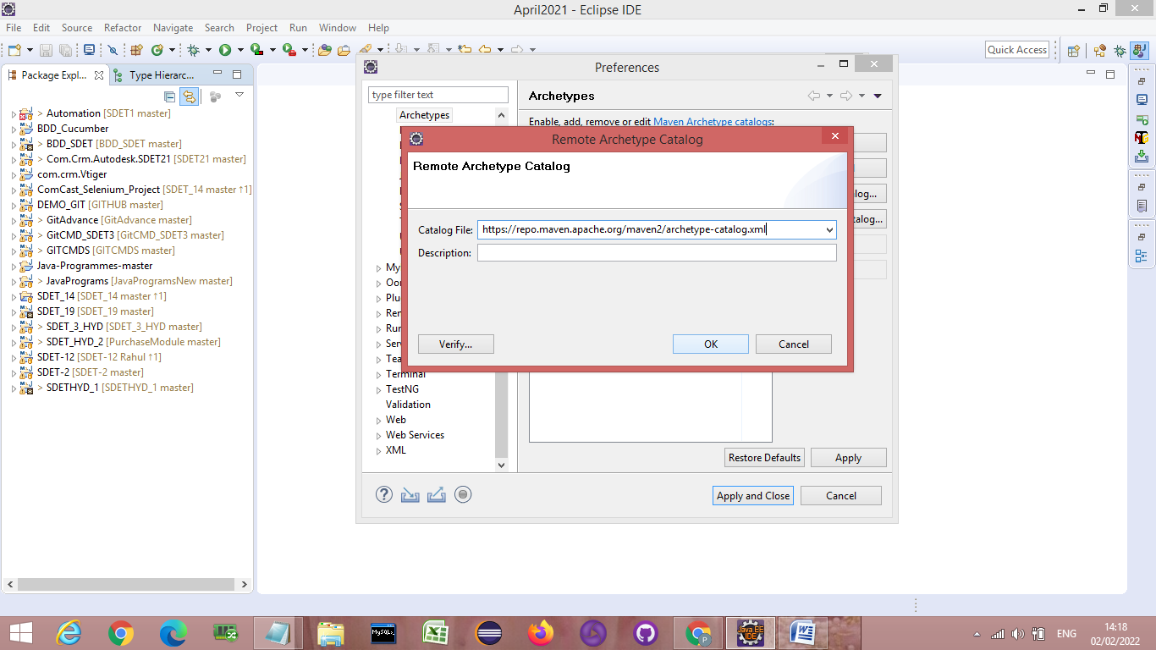

**🡪**Click on Apply and Close 🡪 This will start downloading Archetype make sure you are connected to good network connection.

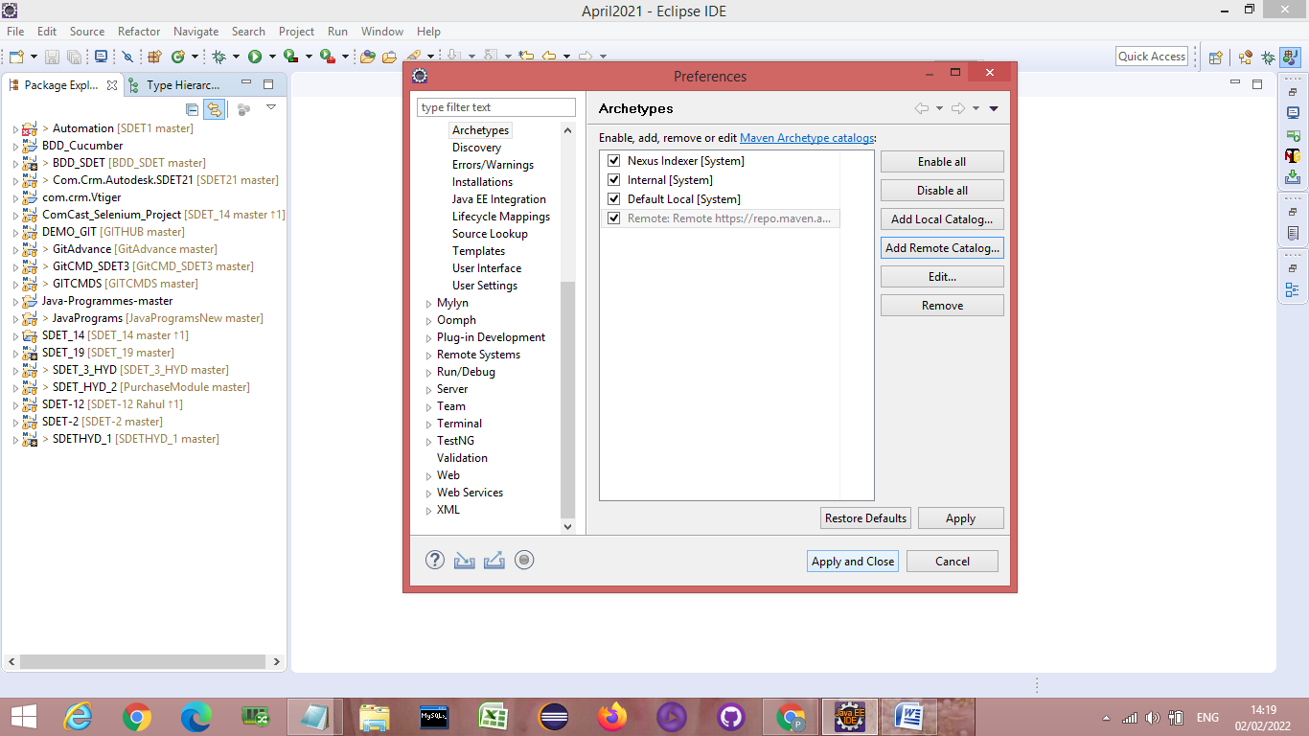

**🡪In the filter textbox type 🡪maven-archetype-quickstart 🡪 You will get 3 suggestion 🡪Select**

**maven-archetype-quickstart 1.4🡪then click on Next**

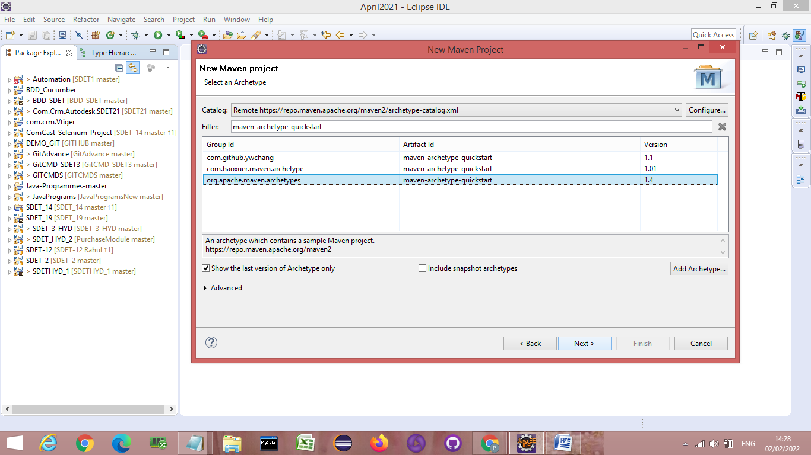

**🡪Fill the below details in textboxes**

* **Group Id : DEMO_MAVEN_Project**
* **Artifact Id : DEMO_MAVEN_Project**

**Then click on Finish 🡪 Maven Project will be created**

